Reflects TraveL

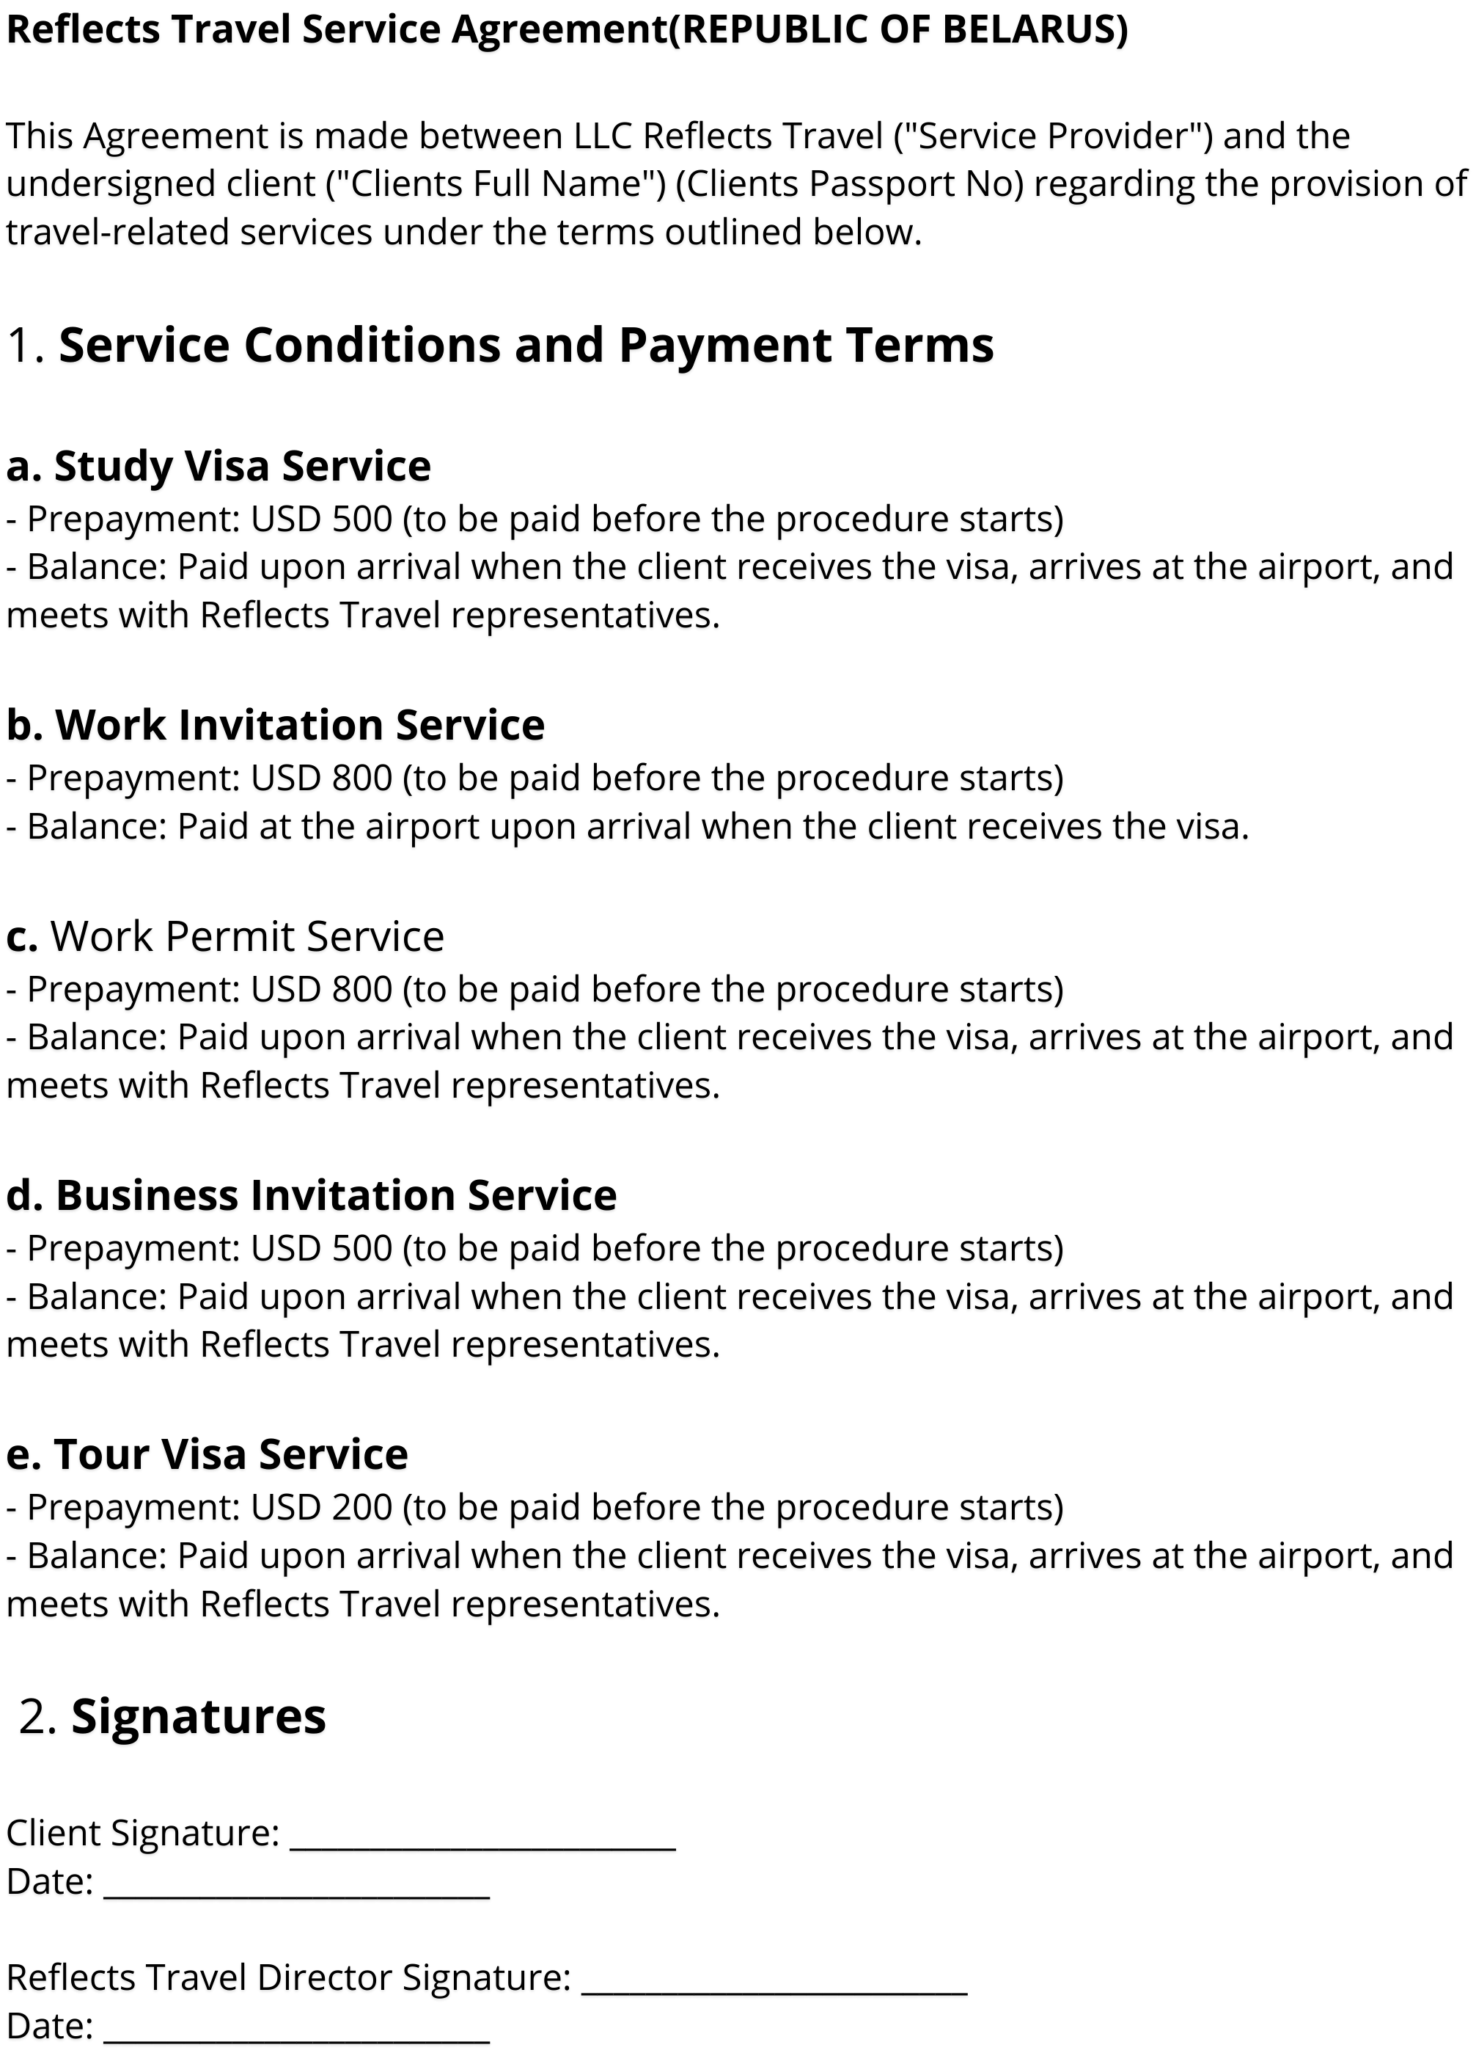

Unlock TraveL Secrets

ZUBACHEVA 3, MINSK BELARUS

+375 25 726 2144

[INFO@REFLECTSTRAVEL.COM](mailto:INFO@REFLECTSTRAVEL.COM) REG NO - 193702197



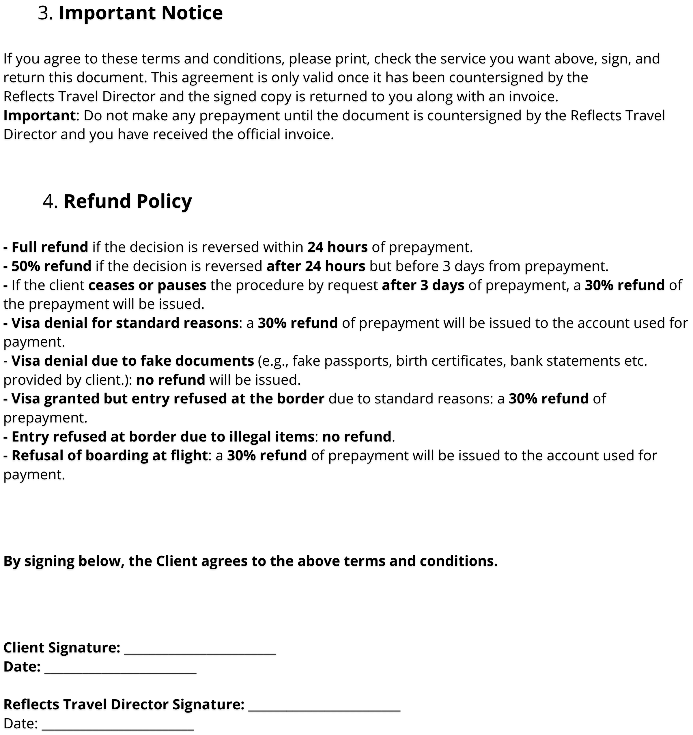

[WWW.REFLECTSTRAVELS.COM](http://WWW.REFLECTSTRAVELS.COM/)